Chapter 14, Solution 64.

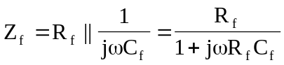

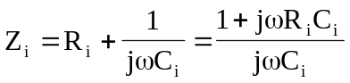

Hence,
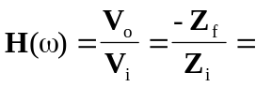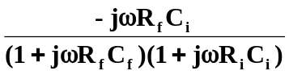

This is a bandpass filter. 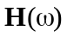 is similar to the product of the transfer function of a lowpass filter and a highpass filter.

